**DOCUMENT: STRIKE 5**



**PROJECT ON**

STRIKE 5

Developed by

**Name**: Cao Minh Duc **Name**: Dao Ngoc Nam

**Reg. No.**: 0973.358.604 **Reg. No.**: 0904.637.912



**Strike 5**

**(Project Title)**

**Batch Code :** B01010

**Start Date :** Jan 1st , 2012

**End Date :** Jan 30th, 2012

**Name of the Coordinator :** Pham Tuan

**Name of Developers :** Cao Minh Duc, Dao Ngoc Nam.

**Date of Submission :** Feb 1st, 2012



**CERTIFICATE**

This is to certify that this report, titled *Strike 5*, embodies the original work done by Cao Minh Duc and Dao Ngoc Nam in partial fulfillment of their course requirement at NIIT.

Coordinator: Pham Tuan

**ACKNOWLEDGEMENT**

We have benefited a lot from the feedback and suggestions given to us by Mr. Pham Tuan and other faculty members.

**SYSTEM ANALYSIS**

**System Summary:** Strike 5 is a computer game that will help players sharpen their brains and improve their concentration. This game is designed for two players to play.

WORKS DIVISION

**Dao Ngoc Nam :** System analysis , code about logic game, testing.

**Cao Minh Duc :** System analysis, code about interface, connect DB.

|  |
| --- |
| **INTERFACE DESIGN FOR STRIKE 5** |

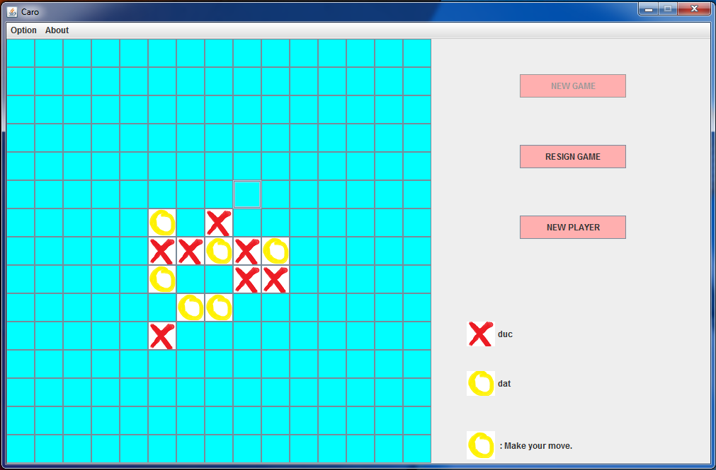

*Interface when playing game*

|  |
| --- |
| **INTERFACE DESIGN FOR STRIKE 5 (cont)** |

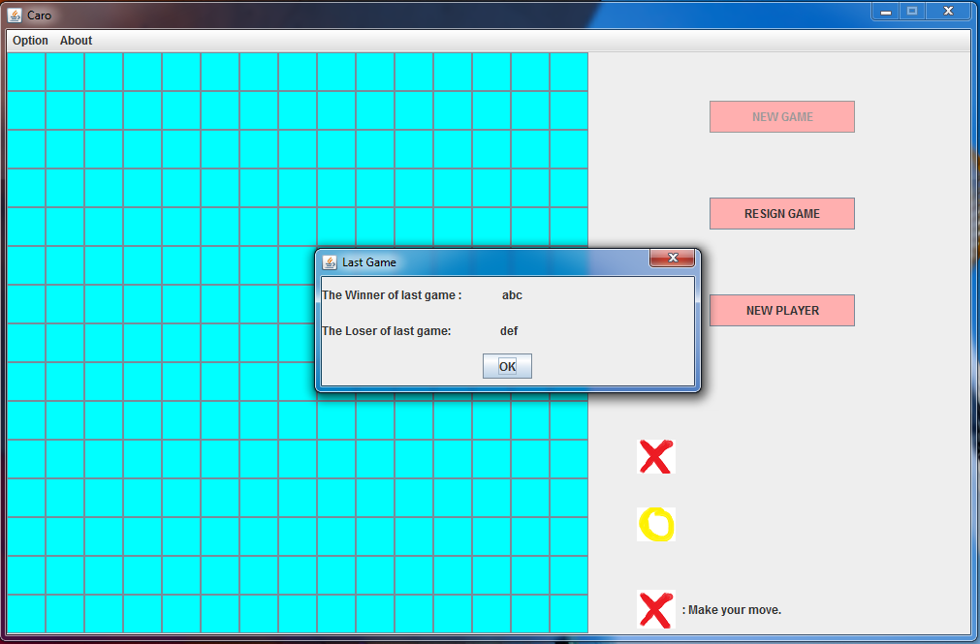

*Infomation of last game*

|  |
| --- |
| **INTERFACE DESIGN FOR STRIKE 5 (cont)** |

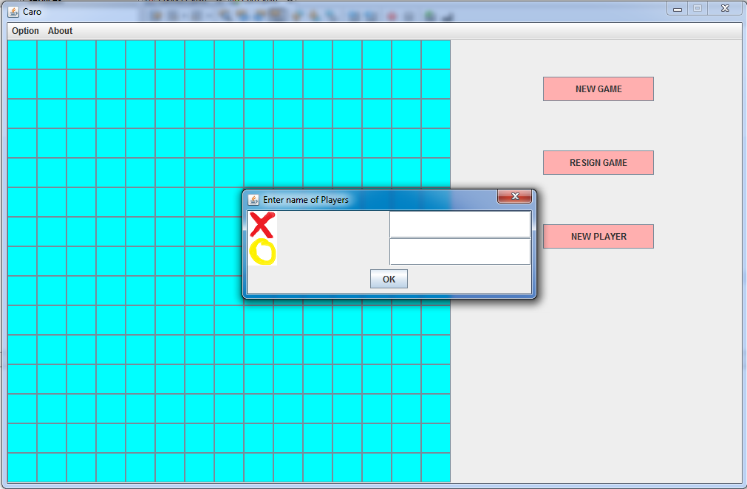

*Form enter name of players*

|  |
| --- |
| **DATABASE TABLE** |

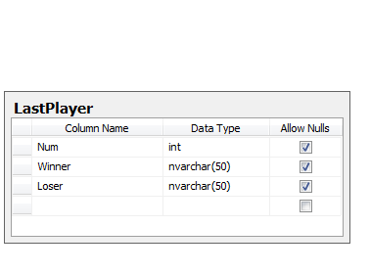

|  |
| --- |
| **CONFIGURATION** |

**Hardware:** PC compatible with Intel core 2 duo processor, 4GB RAM, and 250GB

of Hard disk

**Operating system:** Window 7

**Software:** Netbean IDE 7.01 (Build 201104080000)

SQLserver 2005 Express.